The Machine Learning Process for Solving Real-world Problems

1.1 Understanding the Problem
When you have been given a certain problem to solve or you realise that there is one that needs to be solved using machine learning, there are a couple of steps that you need to undertake so to get the optimal solution.
The first step could be understanding the problem. Problems come in different forms and each requires a unique technique to solve it and in order to deduce that information we need to deeply understand the problem. When analysing the problem, we can start from the desired output and go towards the problem and requirements or we can start from the requirements and head towards the solution. These can be said to be forward and backward reasoning.
Forward reasoning begins with the known facts and attempts to move towards the desired goal and backward reasoning begins with the goal and sets up subgoals which must be solved in order to solve the main problem.
In terms of reasoning, we may define these two kinds of problem analysis as induction and abduction learning. Induction reasoning is the generalization from cases that seen – known, to infer information about cases unseen. Abduction is the process of reasoning back from something to the state or event that caused it.
In short, we may conclude that it is vital to getter information about the problem that you are working on so that you can better understand and from that understanding we can then make assumption of how the whole process should look like and that will serve as a guideline or road map to getting the output.
1.2 Understanding the Task
The uniqueness of the problem resembles the task to be used when solving the problem. In machine learning and data science there are defined tasks from which a problem may reside and a list of them is below:
- Regression
- Classification
- Clustering
- Dimension reduction
- Pattern Search
- And many more
These tasks are usually dependent of the solution. If the solution needs you to categorise some entities, then it might be ideal to go for classification or if the problem wants use to predict some quantitative output that may be most often continuous then we are going to opt for a regression because builds best models on that field.
In most instances the task is heavily linked to the machine learning technique that we are going to use. That is to say, for instance, regression and classification falls under the supervised machine learning technique while clustering, pattern search, and dimension reduction belong to the unsupervised technique.
Determining the technique is simple looking over the given dataset and check to see if the data is labelled of unlabelled. Labelled data comes with the desired output and this helps the model to learn the associations or patterns between the features and the label. Unlabelled data does not come with the labels but it is only the features and here the model needs to find the commonalities from the natural input. Labelled data is used under supervised technique and the unlabelled data is used under unsupervised learning technique.

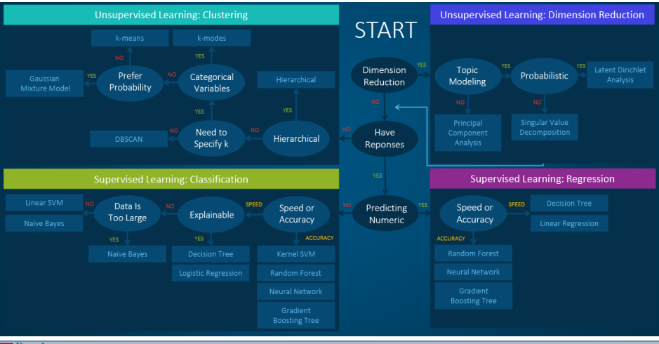
Figure 1 Map for Getting the Best Model

From Figure 1 above we can deduce the steps that can be taken by the machine learning engineer in order to decide what learning technique to use, the task to implement and the algorithm to use for that task.
In order for us to determine the machine learning algorithm to use we need to add on the mentioned information and wea re going to add the following considerations.
- Is the data labelled?
- Training time required
- Number and importance of features
- Data size (Dimension of the data – curse of cardinality
- Interpretability of the model
- Assumptions
The answers to the considerations above can help you navigate to the best algorithms that you can train for that specific problem. Figure 1 shows the paths to take that can help you navigate about.

Research on the Problem
The machine learning community is wide and people research frequently and most importantly, they release their research finding online so with that being said the next step on the machine learning problem solving paradigm is research the common approaches on that problem.
It is important to note that their findings are not met implemented by you since you may have different data than they had. The solution to a ML problem depends on the data; there is no free lunch for the data miner/ data scientist/ machine learning engineer. That means that there is not best optimal model that can be taken from research papers and implemented but we need to find the best one using our own data.
Since we are data dependent, it now brings an aspect of data mining – CRISP-DM, which introduces the concept of business understanding, the business being the use or the need for the machine learning model. We need to deeply understand the use of the model and that will second the fact that we don’t need to use the solutions that are recommended by research papers as the were also investigating their own need for machine learning in their business use.
The research is meant to guide you and maybe give you a methodology that you can adopt since you are also dealing with the same task or problem. In most instances the work that you are tasked to do has previously been done, but maybe in a different approach or for a unique purpose, so this means that the research should be done yet not heavily sticking to it. Personal innovation and creativity is key to finding the solution of your downstream task.
Tackle the problem
Once you have information about the problem, it is time to start doing the job. ML has the advantage of having a structured approach like knowing the steps you can do and the chronology of them – which tends to be mandatory.

A .Data collection
Data collection involves gathering relevant data that represents the problem domain or phenomenon under study. This can include structured data from databases, spreadsheets, or APIs as well as unstructured data like images, text, audio. The data should be comprehensive, diverse, and representative of the patterns or relationships one wishes to discover.
Data collection can involve various methods such as surveys, experiments, web scraping, or accessing existing data sets. Primary and secondary data. It is crucial to ensure data quality, and ethical considerations, such as data privacy and consents.
B .Data pre-processing
This is a crucial step to clean, transform, and prepare the data for analysis. It involves handling outliers missing values, normalising or scaling features and encoding categorical variables. It ensures that data is in a suitable format for the subsequent steps and helps mititgate the impact of noisy and inconsistent data.

C .Feature extraction and Feature Engineering
Feature extraction involves selecting or creating relevant features that capture the underlying patterns in the data. It aims to transform the raw data into a more meaningful representation that the machine learning algorithm can effectively utilized. Techniques used are PCA, T-SINE, LDA, TF-IDF (text), or image feature extraction (images.)
Secondly, it is very vital to perform some feature engineering

This is the process of making sure that the features that are used to train the machine learning model are the ones that are useful. This is done so to prevent adding redundant features that will poorly affect the performance of the model. The model becomes poor because its regularization ability will be reduced and thus not performing well on unseen data. Further, adding more features to the model increases the complexity of the model which will cause over-fitting.
Feature engineering can be done manually or automatically. Manual feature engineering is subject to the ideas and the imagination of the person that performed it. It can be done by thoroughly understanding the domain and getting only the best features as per that domain and use them to build the machine learning model. Unsurprisingly, this task is tedious and prone to human error – consequently the model will learn bad behaviour that bring about the idea of automated feature engineering.
Automated feature engineering is a technique that pulls out useful and meaningful features using a framework that can be applied to any problem. The most popular feature engineering frameworks are:
- Feature Tools
- TSFresh
- Featurewiz
- PyCaret
Feature selection is one feature engineering technique that can be implemented so to select only the features that are important.
Classical feature engineering techniques
- Forward feature selection
- Backward feature elimination
- Analysis of variance
- Chi-squared
- Recursive feature elimination
- Etc

D .Model selection
Model selection involves choosing an appropriate machine learning algorithm or model architecture that is well-suited for the problem at hand. The choice of model depends of factors such as the nature of the data, the problem types, computational constraints and interpretability requiremsnts.
A wide range of algorithms exist nowadays from which one can choose, ranging from the state-of-the-art machine learning to deep learning and sometimes the combination of the two is utilised to harness the power of each of them.

E .Training the model
Once the model is selected, it needs to be trained on a subset of the data, often referred to as the training set. During the training process, the model learns the underlying patterns and relationships in the data by adjusting its internal parameters. The objective is to minimize a defined loss or error function that quantifies the disparity between the predicted outputs and the ground truth.
Model training involves iterative optimization algorithms, such as gradient descent, which update the model’s parameters based on the training data. The process continues until the model reaches a satisfactory level of performance or convergence.

F .Validation and testing
After training, the model’s performance need to be evaluated using data that it has not seen before. This is typically done using a validation set and a test set. The validation set is used to fine-tune the model’s hyper-parameters and make adjustments to improve its generalisation capability. The test set is used to provide as unbiased evaluation of the final model’s performance. Evaluation metrics depend on the specific problem

G .Fine-tuning the model
Based on the performance evaluation, adjustments and fine-tuning of the model may be necessary, this can involve iterating on the model’s hyperparameters such as learning rate, regularization strength, or network architecture, to improve performance. Techniques like cross-validation can be employed to estimate the generalisation performance of the model and guide the fine tuning.
Fine-tuning aims to strike a balance between underfitting (model lacks complexity) and overfitting ( model memorised the training data but fails to generalise to new data.)

H .Deployment
Once the model has been trained and fine-tuned, it is ready for deployment in the real-work application or environment. Deployment involves intergratinig the model into an application or system where it can be utilised for making predictions or providing insights.
Depending on the use case, deployment can range from embedding the model in software, deploying it as a web service or API, or even deploying it on edge devices for real-time interference. Deployment considerations include scalability, performance, security, and monitoring of model performance in production.

I .Feedback loop
The feedback loop is an important step that involves collecting feedback on the model’s performance in the real-world setting. This can come from user feedback, monitoring performance metric, or comparing predictions against ground truth values. The feedback loop helps identify and address any issues or limitations in the deployed model.
Feedback can be used to refine the model, update training data, of make adjustments to the model’s architecture or hyper-parameters. It ensures continuous improvements and adaptation of the model based on real-world experiences.

J .Inference
Inference refers to the process of ofusing the trained model to make predictions or generated outputs on new, unseen data. This is the final step in the machine learning pipeline. During inference, the model takes input data and applies the learned patterns and relationships to produce prediction or outputs.
Inference can be performed in real-time or batch mode, depending of the application requirements. It involves feeding the input data to the trained model, which applies the learned transformation and calculations to generate the desired outputs.
The output of the inference step can be used for various purposes, such as making predictions, detecting, recommending and classifications. The quality and accuracy of the inference depend on the quality of the trained model and the suitability of the input data.

